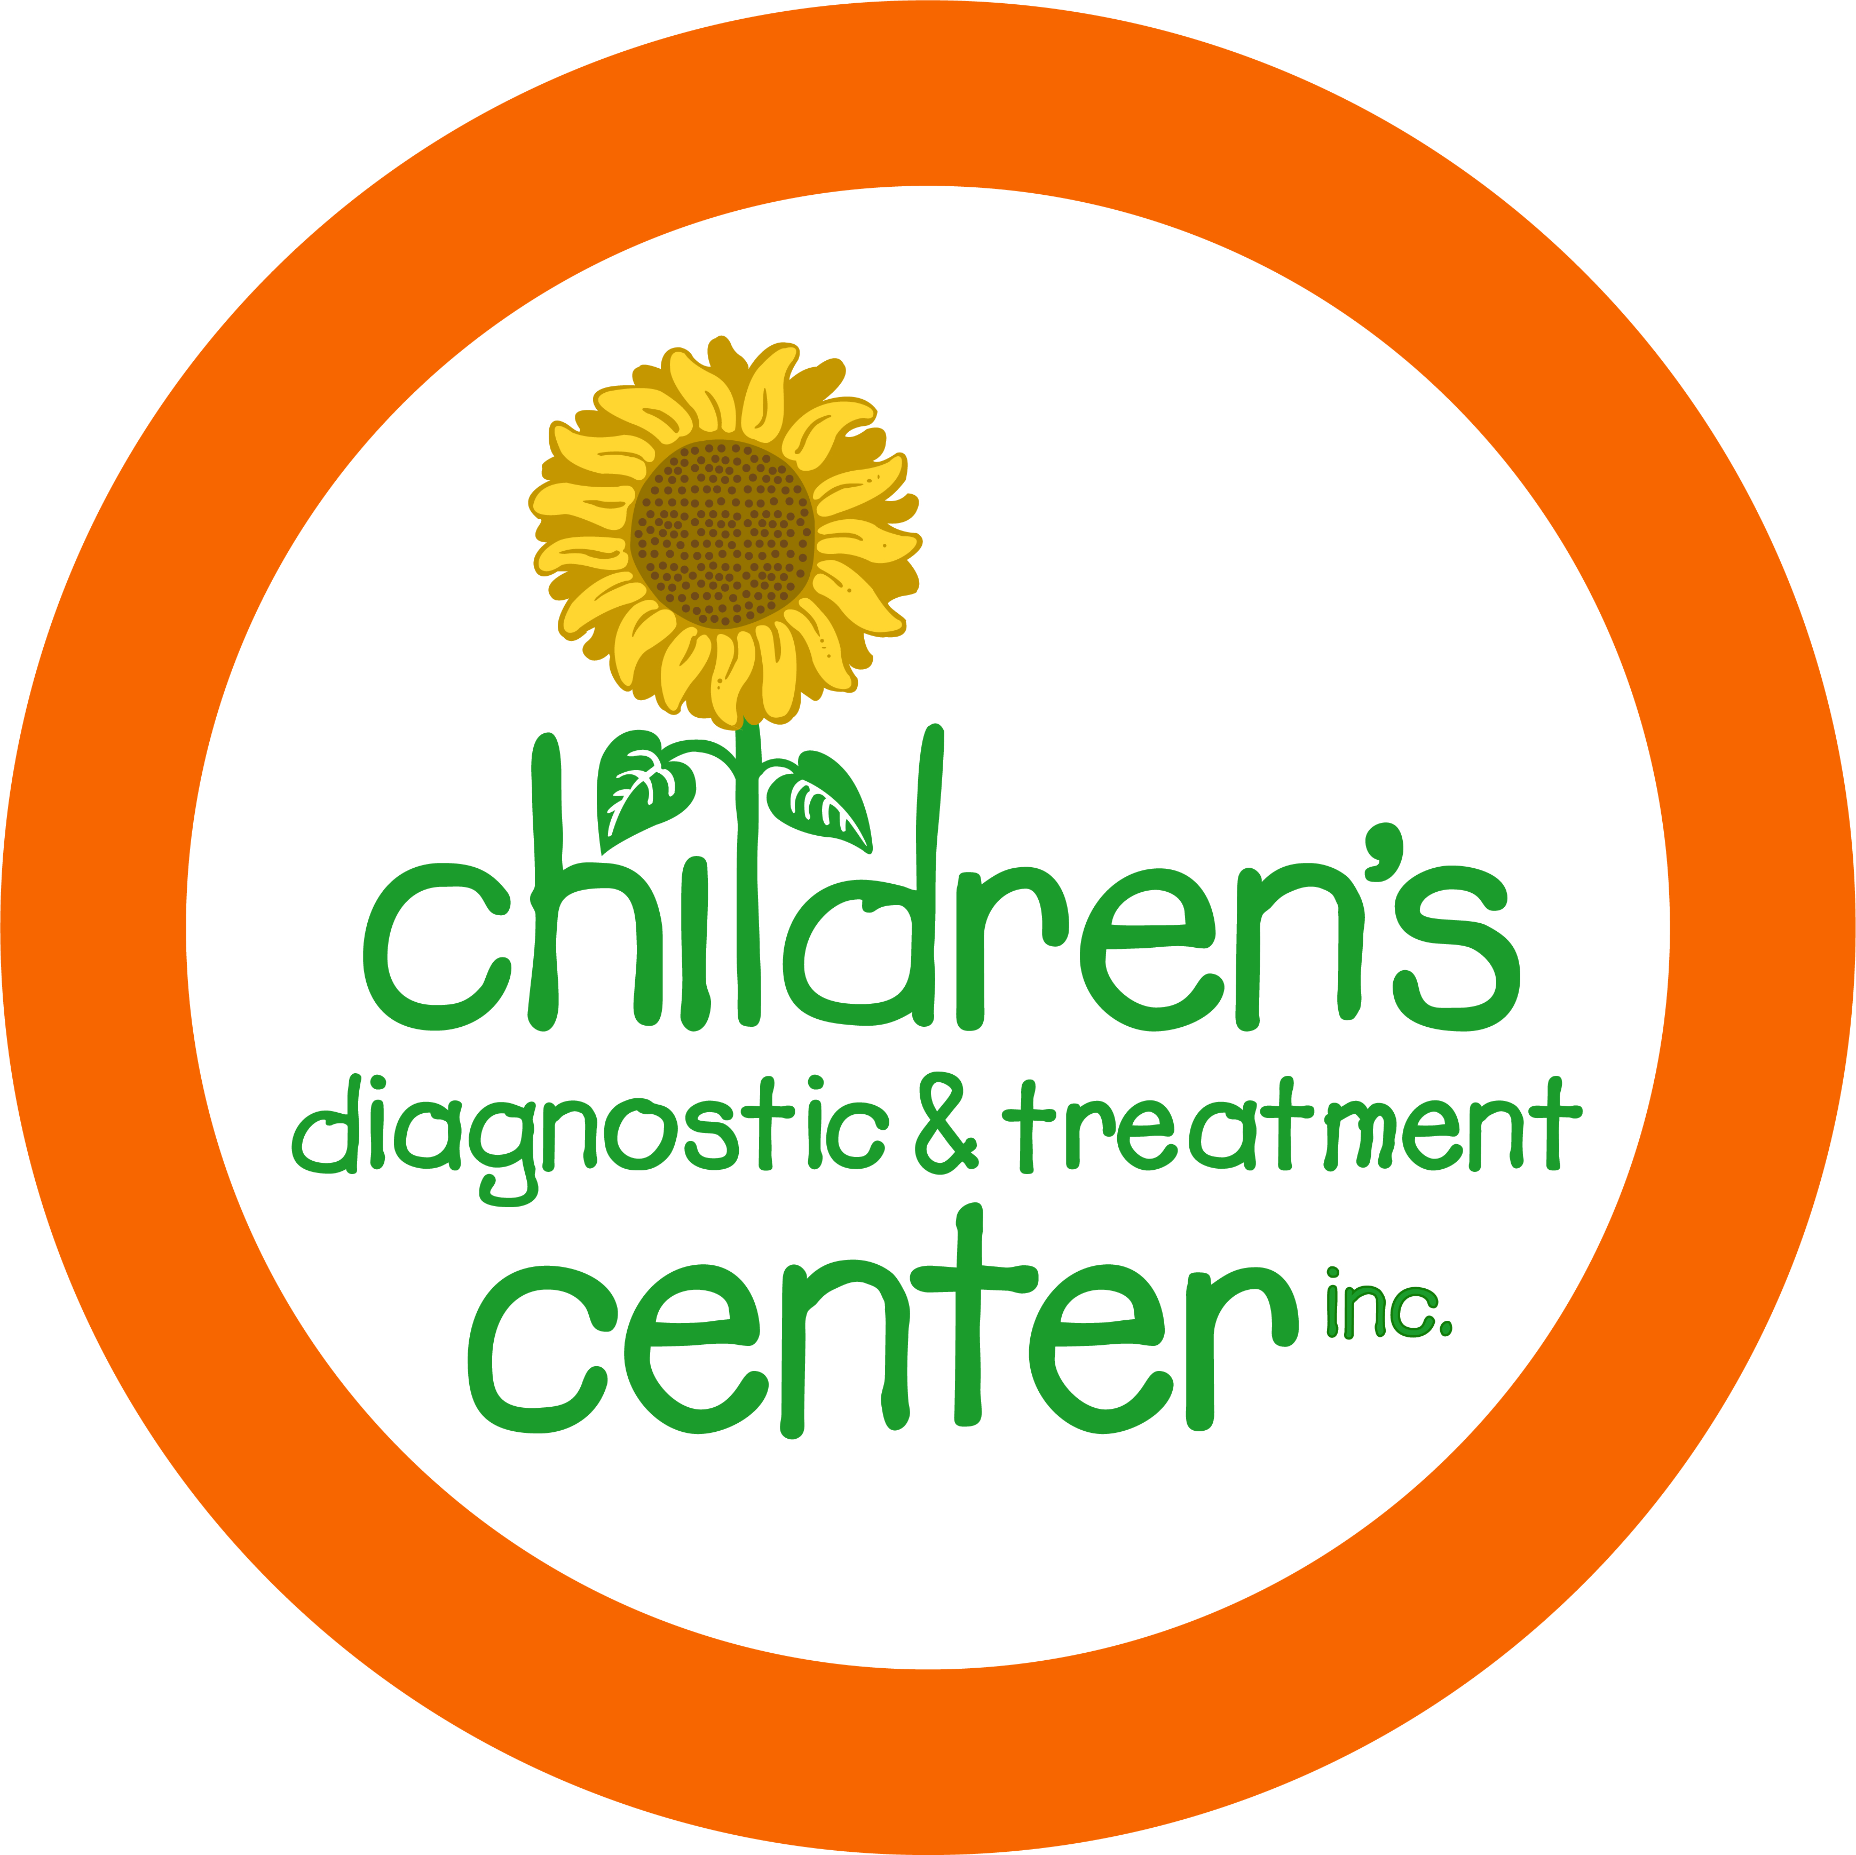
Volunteer Application

Thank you for your interest in becoming a member of Children’s Diagnostic & Treatment Center’s Volunteer Program. Completing and returning this application is the first step; it will be followed by an interview and orientation, after which a volunteer assignment and schedule may be arranged.
Please be aware that as an outpatient health care facility, the Center has few opportunities to participate directly with the children. Most volunteer positions support the Center’s programs and services.
Please complete the application below by printing clearly in pen or typing. Applications may require up to four weeks to process.

Name:
Address:
City: State: Zip:
Best Phone Number:
E-mail:

Date of Birth / / Student: YES NO
If a student, what school? When do you graduate? ________
Current Employment: Position:

What Volunteer Activities Are You Interested In? (circle all that apply)
Office Assistance Special Events
Donation Drives / Collections Food / Donation Pantry

What Days Are You Available?
Monday Tuesday Wednesday Thursday Friday Weekends | Mornings Afternoons
Specific Hours Preferred:
Languages: English Spanish Creole Other:
Please provide TWO personal references:
Name: Phone: Relationship:
Name: Phone: Relationship:

STUDENTS PLEASE NOTE: Students under the age of 18 must provide recommendations from two teachers as well as the community service paperwork required by Broward County Public or Private Schools.
_____________________________________________ __________________________
Signature Date

Interview Date:________________________ Interviewer:__________________________________________________________

Orientation Date:______________________ Volunteer Position:_____________________________________________________

Volunteer Schedule:____________________________________________________________________________________________

 Signed Confidentiality Statement  Signed Photo Release

Return to: Gloria Raymond at gwraymond@browardhealth.org or mail to her attention at the address below.

cdtc
1401 S Federal Highway; Fort Lauderdale, FL 33316
954-728-1019 | www.childrensdiagnostic.org

